Physical Science Year 7

Topic Test

Name: _______________________________________ Total: 65 marks

Part A: Multiple-Choice (10 marks)

1. A force is applied when something is:

**A** pushed, pulled or torn.

**B** pulled, pushed or twisted.

**C** twisted, pulled or attracted.

**D** pushed, twisted or torn.

2. A force can change:

**A** the direction something is moving.

**B** the speed something is moving at.

**C** the shape of an object.

**D** all of the above.

3.Which of the following is **correct**:

**A** the more massive something is, the greater its inertia.

**B** the less massive something is, the greater its inertia.

**C** the more massive something is, the less its inertia.

**D** the mass of something has no effect on inertia.

4. **Active** safety features are designed to reduce the chance of an accident happening. **Passive** safety features lessen the possible damage to the occupants when an accident **does** happen.

Which of the following are all **active** safety features?

**A** good tyres, anti-lock brakes, airbags.

**B** electronic stability control, good tyres, reversing sensors.

**C** seatbelts, airbags, crumple zones.

**D** seatbelts, good tyres, reversing sensors.

5. Which of the following are **all** methods to reduce friction?

**A** adding weight, rough surfaces, polishing.

**B** rough surfaces, wheels, lubricants.

**C** lubricants, air-layers, streamlining.

**D** polishing, increase surface area, rough surfaces.

6. Which of the following statements about gravity is true?

**A** gravity is a contact force.

**B** gravity pushes objects towards the Earth.

**C** all objects naturally attract each other.

**D** all of the above.

7. Atoms are made up of the following subatomic particles:

**A** protons, neutrons and electrons.

**B** positive, neutrons and electrons.

**C** protons, negatives and electrons.

**D** protons, negatives and static.

8. Static electricity occurs when:

**A** insulators move from one charged object to another.

**B** neutrons move from one charged object to another.

**C** protons move from one charged object to another.

**D** electrons move from one charged object to another.

9. If the following forces are acting on an object it will move:

|  |  |  |  |
| --- | --- | --- | --- |
| Force to left (N) | Force to right (N) | Force upwards (N) | Force downwards (N) |
| 20 | 30 | 0 | 0 |

**A** right.

**B** left.

**C** upwards.

**D** downwards.

10. A wheelbarrow is an example of a:

**A** first-class lever.

**B** second-class lever.

**C** third-class lever.

**D** fourth-class lever.

**Part 2: Short Answer**

1. **Match** the following terms with their correct meaning. Note: not all words will be used.

Force, Newton, friction, lubricant, gravity, mass, weight, non-contact force, contact force,

atoms, insulator, conductor, poles, repel, attract, balanced force, unbalanced force, inertia,

aurora, magnetic field.

a) The amount of matter in an object ______________ mass

b) Allows electrons to flow through ______________ conductor

c) When two forces are equal and opposite ________ balanced force

d) The unit used to measure forces ______________ Newton

e) The ends of a magnet ______________________ poles

f) A contact force present when two objects are in contact ____ friction

g) The tendency of an object in motion to continue moving ___ inertia

h) A force of attraction between two objects ___________ gravity

i) When two poles push each other away _____________ repel

j) A spectacular light show near the poles _____________ aurora

(10 marks)

2. a) **Draw** and **label** a north and north pole, south and south pole and north and south pole being placed near each other:

NN

(4 marks)

b) **Describe** how friction can be both useful and a nuisance. Give examples ________________

It can be useful when tyres get some grip and the car moves forward.

It can be a nuisance when your tyres wear out due to friction. Any similar!

(4 marks)

3. Simple machines can make a task easier:

1. **State** two ways they can make a task easier ___ change the force required, change the

direction, change the speed.

1. **Name** two simple machines _ lever, pulley, wheel and axle, inclined plane, screw, gears.

(4 marks)

4. **Justify** the following statement:

1. It is easy to reduce friction.

Yes it is easy. Need to name at least two methods to reduce friction and a short explanation.

Streamlining, air-layers, lubricants, rollers, ball-bearings, polishing

(2 marks)

5. **Explain** how mass is different to weight __________________________________________

Mass is how much matter an object has in it and does not change when gravity changes.

Weight is the force of gravity acting on an object and changes if gravity changes. Eg, the

moon and Earth.

(2 marks)

6. **Classify** the following as contact or non-contact:

1. gravity _______________________ NC
2. friction _______________________ C
3. electrostatic ___________________ NC
4. magnetic _____________________ NC

(4 marks)

7. **Identify** whether the following are increasing or decreasing friction:

1. Oil in an engine ___________________ decreasing
2. Tread on a tyre ___________________ increasing
3. Polishing the bottom of a boat_______ decreasing

(3 marks)

8. The following picture shows a type of simple machine:

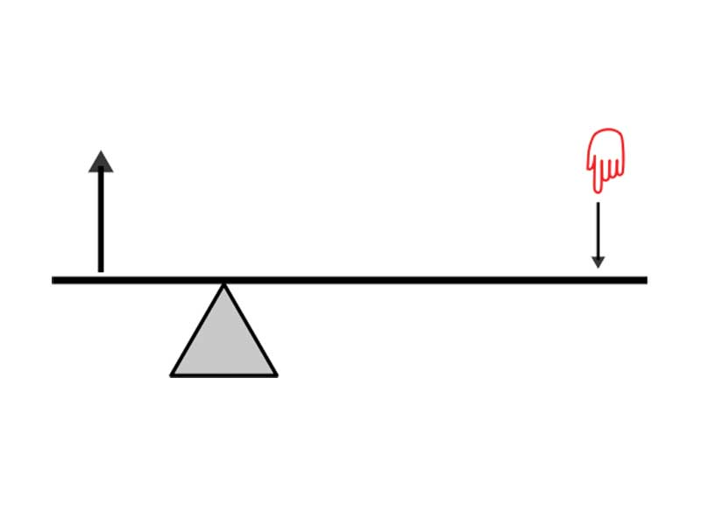

B

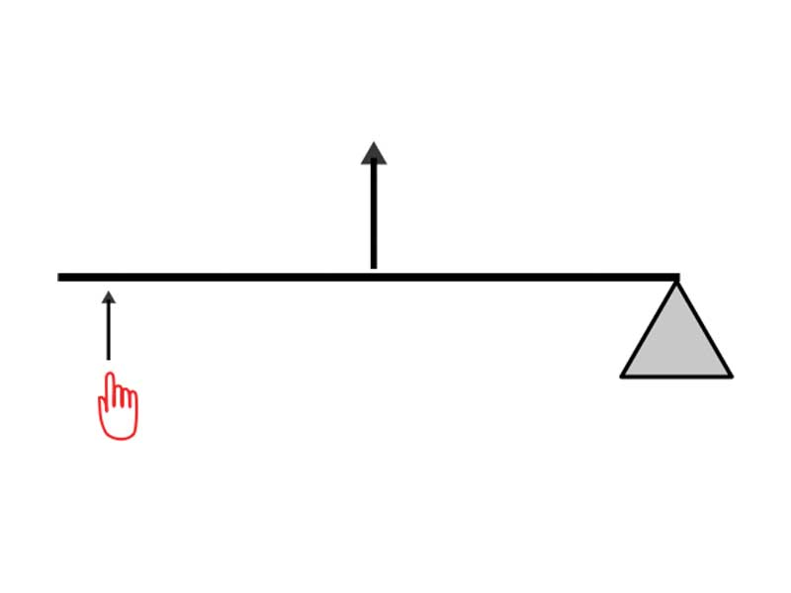

A

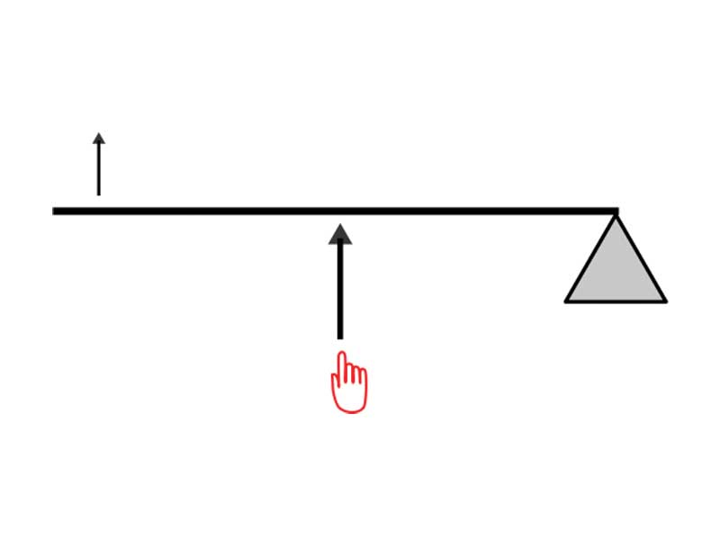

C

a) **Identify** the name of this type of simple machine _________ levers

(1 marks)

b) **Identify** which class of this simple machine B is _________ 1st

(1 mark)

c) **Identify** the parts of this type of simple machine __ Effort, Load, Fulcrum.

___________________________________________________________________________

(3 marks)

9. The following table shows the results of a friction experiment.

|  |  |  |  |  |
| --- | --- | --- | --- | --- |
| Mass of Object (g) | Friction Force Measured (N) | | | Average Friction |
| Trial 1 | Trail 2 | Trial 3 |
| 100 | 2.1 | 2.1 | 1.8 | **2.0** |
| 200 | 3.9 | 4.0 | 4.1 | **4.0** |
| 300 | 5.7 | 6.3 | 6.0 | **6.0** |
| 400 | 7.8 | 7.8 | 8.4 | **8.0** |
| 500 | 9.9 | 9.9 | 10.2 | **10.0** |
| 600 | 12.1 | 11.9 | 12.0 | **12.0** |
| 700 | 14.2 | 13.7 | 14.1 | **14.0** |
| 800 | 16.0 | 15.9 | 16.1 | **16.0** |
| 900 | 17.7 | 18.1 | 18.2 | **18.0** |
| 1000 | 19.9 | 20.1 | 20.0 | **20.0** |

a) Graph the **average** results above as a line graph. (6 marks)

b) What was the **maximum** friction force measured in any trial? ____ 20.1

(1 mark)

c) What was the **range** in the average friction recorded? _____ 18

(1 mark)

d) **Compare** the friction force of 200g and 700g ________________________________

200g was 4N and 700g was 14N. 200g was 10N more than 700g. 700g was 3.5 times

more than 200g

(2 marks)

e) **Estimate** the average friction force if the mass is 1100g ________ 22N

(1 mark)

f) **Estimate** the average friction force if the mass is 650g _________ 13N

(1 mark)

10. **Define** the following:

i) Force __ A push, a pull or a twist.

___________________________________________________________________________

ii) Fulcrum ____ The point around which a lever pivots.

___________________________________________________________________________

iii) Temporary magnet ____ a piece of metal that acts like a magnet for a short while.

___________________________________________________________________________

iv) Acceleration ______ to speed up

___________________________________________________________________________

v) Atom ______building blocks of all matter

___________________________________________________________________________

(5 marks)